**Java Concurrency** is a term that covers multithreading, concurrency and parallelism on the Java platform.

Back in the old days a computer had a single CPU, and was only capable of executing a single program at a time. Later came multitasking which meant that computers could execute multiple programs (AKA tasks or processes) at the same time. It wasn't really "at the same time" though. The single CPU was shared between the programs.

Multithreading can be a great way to increase the performance of some types of programs. However, mulithreading is even more challenging than multitasking. The threads are executing within the same program and are hence reading and writing the same memory simultaneously. This can result in errors not seen in a singlethreaded program. Some of these errors may not be seen on single CPU machines, because two threads never really execute "simultanously". Modern computers, though, come with multi core CPUs, and even with multiple CPUs too. This means that separate threads can be executed by separate cores or CPUs simultanously.

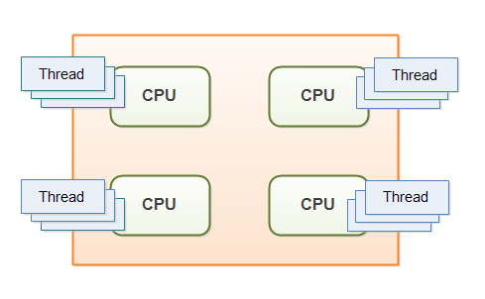

If a thread reads a memory location while another thread writes to it, what value will the first thread end up reading? The old value? The value written by the second thread? Or a value that is a mix between the two? Or, if two threads are writing to the same memory location simultaneously, what value will be left when they are done? The value written by the first thread? The value written by the second thread? Or a mix of the two values written?

Without proper precautions any of these outcomes are possible. The behavior would not even be predictable. The outcome could change from time to time. Therefore it is important as a developer to know how to take the right precautions - meaning learning to control how threads access shared resources like memory, files, databases etc. That is one of the topics this Java concurrency tutorial addresses.

**Multithreading Benefits**

The reason multithreading is still used in spite of its challenges is that multithreading can have several benefits. Some of these benefits are:

1. **Better resource utilization:** Imagine an application that reads and processes files from the local file system. Lets say that reading a file from disk takes 5 seconds and processing it takes 2 seconds. Processing two files then takes

5 seconds reading file A

2 seconds processing file A

5 seconds reading file B

2 seconds processing file B

-----------------------

14 seconds total

When reading the file from disk most of the CPU time is spent waiting for the disk to read the data. The CPU is pretty much idle during that time. It could be doing something else. By changing the order of the operations, the CPU could be better utilized. Look at this ordering:

5 seconds reading file A

5 seconds reading file B + 2 seconds processing file A

2 seconds processing file B

-----------------------

12 seconds total

The CPU waits for the first file to be read. Then it starts the read of the second file. While the second file is being read, the CPU processes the first file. Remember, while waiting for the file to be read from disk, the CPU is mostly idle.

1. **Simpler program design in some situations:**  If you were to program the above ordering of reading and processing by hand in a singlethreaded application, you would have to keep track of both the read and processing state of each file. Instead you can start two threads that each just reads and processes a single file. Each of these threads will be blocked while waiting for the disk to read its file. While waiting, other threads can use the CPU to process the parts of the file they have already read. The result is, that the disk is kept busy at all times, reading from various files into memory. This results in a better utilization of both the disk and the CPU. It is also easier to program, since each thread only has to keep track of a single file.
2. **More responsive programs:** Another common goal for turning a singlethreaded application into a multithreaded application is to achieve a more responsive application. Imagine a server application that listens on some port for incoming requests. when a request is received, it handles the request and then goes back to listening. The server loop is sketched below:

while(server is active){

listen for request

process request

}

If the request takes a long time to process, no new clients can send requests to the server for that duration. Only while the server is listening can requests be received.

An alternate design would be for the listening thread to pass the request to a worker thread, and return to listening immediately. The worker thread will process the request and send a reply to the client. This design is sketched below:

while(server is active){

listen for request

hand request to worker thread

}

This way the server thread will be back at listening sooner. Thus more clients can send requests to the server. The server has become more responsive.

**Multithreading Costs:** Don't just multithread-enable an application just because you can. You should have a good idea that the benefits gained by doing so, are larger than the costs. When in doubt, try measuring the performance or responsiveness of the application, instead of just guessing.

1. **More Complex design :** Code executed by multiple threads accessing shared data need special attention. Errors arising from incorrect thread synchronization can be very hard to detect, reproduce and fix.

* When a CPU switches from executing one thread to executing another, the CPU needs to save the local data, program pointer etc. of the current thread, and load the local data, program pointer etc. of the next thread to execute. This switch is called a "context switch".

1. **Context Switching overhead :** Saving the context of one process and loading the context of another process is called Context switching.

* Minimum process required for context switching = 2 exception : for round robin case minimum process required for context switching = 1
* Context switching time is considered as the overhead for the system

1. **Increase Resource consumption** : If number of threads are increased ,more memory is required to save their stack information.

**Concurrency Model:**

A *concurrency model* specifies how threads in the system collaborate to complete the jobs they are given. Different concurrency models split the jobs in different ways, and the threads may communicate and collaborate in different ways.

**Concurrency model and Distributed System similarities :** In a concurrent system different threads communicate with each other. In a distributed system different processes communicate with each other (possibly on different computers). Threads and processes are quite similar to each other in nature. That is why the different concurrency models often look similar to different distributed system architectures.

Of course distributed systems have the extra challenge that the network may fail, or a remote computer or process is down etc. But a concurrent system running on a big server may experience similar problems if a CPU fails, a network card fails, a disk fails etc. The probability of failure may be lower, but it can theoretically still happen.

Because concurrency models are similar to distributed system architectures, they can often borrow ideas from each other. For instance, models for distributing work among workers (threads) are often similar to models of [load balancing in distributed systems](http://tutorials.jenkov.com/software-architecture/load-balancing.html).

**Parallel Workers:**

The first concurrency model is what I call the *parallel worker* model. Incoming jobs are assigned to different workers. Here is a diagram illustrating the parallel worker concurrency model:

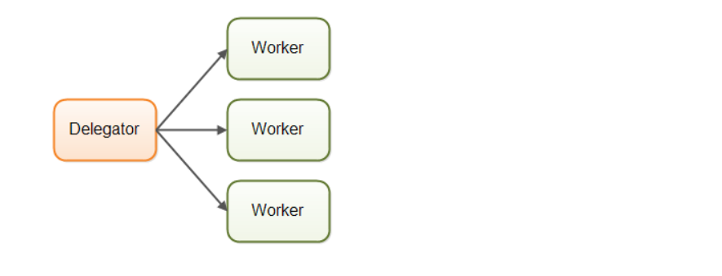

In the parallel worker concurrency model a delegator distributes the incoming jobs to different workers. Each worker completes the full job. The workers work in parallel, running in different threads, and possibly on different CPUs.

If the parallel worker model was implemented in a car factory, each car would be produced by one worker. The worker would get the specification of the car to build, and would build everything from start to end.

* The parallel worker concurrency model is the most commonly used concurrency model

**Advantage of Parallel Workers Model** :

it is easy to understand. To increase the parallelization of the application you just add more workers.

**Disadvantage of Parallel Workers Model** :

### Shared State Can Get Complex:

In reality the parallel worker concurrency model is a bit more complex than illustrated above. The shared workers often need access to some kind of shared data, either in memory or in a shared database. The following diagram shows how this complicates the parallel worker concurrency model:

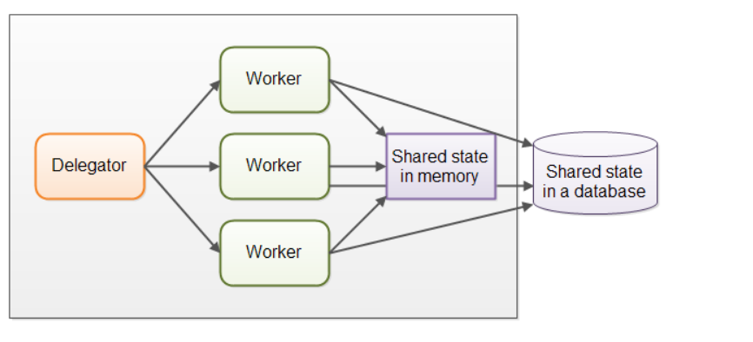

As soon as shared state sneaks into the parallel worker concurrency model it starts getting complicated. The threads need to access the shared data in a way that makes sure that changes by one thread are visible to the others (pushed to main memory and not just stuck in the CPU cache of the CPU executing the thread). Threads need to avoid [**race conditions**](http://tutorials.jenkov.com/java-concurrency/race-conditions-and-critical-sections.html), [**deadlock**](http://tutorials.jenkov.com/java-concurrency/deadlock.html) and many other shared state concurrency problems.

Additionally, part of the parallelization is lost when threads are waiting for each other when accessing the shared data structures.

Modern [**non-blocking concurrency algorithms**](http://tutorials.jenkov.com/java-concurrency/non-blocking-algorithms.html) may decrease contention and increase performance, but non-blocking algorithms are hard to implement.

Persistent data structures are another alternative. A persistent data structure always preserves the previous version of itself when modified. Thus, if multiple threads point to the same persistent data structure and one thread modifies it, the modifying thread gets a reference to the new structure. All other threads keep a reference to the old structure which is still unchanged and thus consistent. The Scala programming contains several persistent data structures.

### Stateless Workers :

Shared state can be modified by other threads in the system. Therefore workers must re-read the state every time it needs it, to make sure it is working on the latest copy. This is true no matter whether the shared state is kept in memory or in an external database. A worker that does not keep state internally (but re-reads it every time it is needed) is called *stateless* .

Re-reading data every time you need it can get slow. Especially if the state is stored in an external database.

### Job Ordering is Nondeterministic :

Another disadvantage of the parallel worker model is that the job execution order is nondeterministic. There is no way to guarantee which jobs are executed first or last. Job A may be given to a worker before job B, yet job B may be executed before job A.

## Assembly Line concurrency model :

In this model The workers are organized like workers at an assembly line in a factory. Each worker only performs a part of the full job. When that part is finished the worker forwards the job to the next worker.



Each worker is running in its own thread, and shares no state with other workers. This is also sometimes referred to as a *shared nothing* concurrency model.

### Actors vs. Channels

Actors and channels are two similar examples of assembly line models.

In the actor model each worker is called an *actor*. Actors can send messages directly to each other. Messages are sent and processed asynchronously.

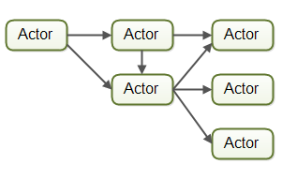

In the channel model, workers do not communicate directly with each other. Instead they publish their messages (events) on different channels. Other workers can then listen for messages on these channels without the sender knowing who is listening.

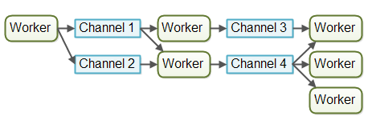

At the time of writing, the channel model seems more flexible to me. A worker does not need to know about what workers will process the job later in the assembly line. It just needs to know what channel to forward the job to (or send the message to etc.). Listeners on channels can subscribe and unsubscribe without affecting the workers writing to the channels. This allows for a somewhat looser coupling between workers.

## Assembly Line Advantages:

### No Shared State

The fact that workers share no state with other workers means that they can be implemented without having to think about all the concurrency problems that may arise from concurrent access to shared state. This makes it much easier to implement workers. You implement a worker as if it was the only thread performing that work - essentially a singlethreaded implementation.

### Stateful Workers

Since workers know that no other threads modify their data, the workers can be stateful. By stateful I mean that they can keep the data they need to operate in memory, only writing changes back the eventual external storage systems. A stateful worker can therefore often be faster than a stateless worker.

**Job ordering is possible :**

It is possible to implement a concurrent system according to the assembly line concurrency model in a way that guarantees job ordering. Job ordering makes it much easier to reason about the state of a system at any given point in time. Furthermore, you could write all incoming jobs to a log. This log could then be used to rebuild the state of the system from scratch in case any part of the system fails. The jobs are written to the log in a certain order, and this order becomes the guaranteed job order. Here is how such a design could look:



Implementing a guaranteed job order is not necessarily easy, but it is often possible. If you can, it greatly simplifies tasks like backup, restoring data, replicating data etc. as this can all be done via the log file(s).

## Assembly Line Disadvantages

The main disadvantage of the assembly line concurrency model is that the execution of a job is often spread out over multiple workers, and thus over multiple classes in your project. Thus it becomes harder to see exactly what code is being executed for a given job.

**Functional Parallelism concurrency model :** The basic idea of functional parallelism is that you implement your program using function calls. Functions can be seen as "agents" or "actors" that send messages to each other, just like in the assembly line concurrency model (AKA reactive or event driven systems). When one function calls another, that is similar to sending a message.

All parameters passed to the function are copied, so no entity outside the receiving function can manipulate the data.

With Java 7 we got the java.util.concurrent package contains the **[ForkAndJoinPool](http://tutorials.jenkov.com/java-util-concurrent/java-fork-and-join-forkjoinpool.html)** which can help you implement something similar to functional parallelism. With Java 8 we got parallel [**streams**](http://tutorials.jenkov.com/java-collections/streams.html) which can help you parallelize the iteration of large collections.

## Which Concurrency Model is Best?

As is often the case, the answer is that it depends on what your system is supposed to do. If your jobs are naturally parallel, independent and with no shared state necessary, you might be able to implement your system using the parallel worker model.

Many jobs are not naturally parallel and independent though. For these kinds of systems I believe the assembly line concurrency model has more advantages than disadvantages, and more advantages than the parallel worker model.

# Same-threading :

# Same-threading is a concurrency model where a single-threaded systems are scaled out to N single-threaded systems. The result is N single-threaded systems running in parallel. A same-threaded system is not a pure single-threaded system, because it contains of multiple threads. But - each of the threads run like a single-threaded system.

# Why Single-threaded System ?

Single-threaded systems have gained popularity because their concurrency models are much simpler than multi-threaded systems. Single-threaded systems do not share any data with other threads. This enables single thread to use non-concurrent data structures, and utilize the CPU and CPU caches better.

Unfortunately, single-threaded systems do not fully utilize modern CPUs. A modern CPU often comes with 2, 4 or more cores. Each core functions as an individual CPU. A single-threaded system can only utilize one of the cores, as illustrated here:

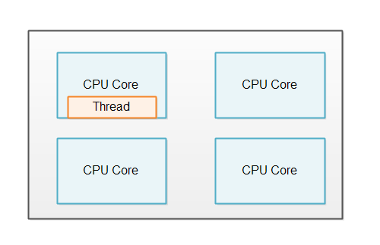

In order to utilize all the cores in the CPU, a single-threaded system can be scaled out to utilize the whole computer.

One Thread Per CPU : If a computer contains 4 CPUs, or a CPU with 4 cores, then it would be normal to run 4 instances of the same-threaded system (4 single-threaded systems). The illustration below shows this principle:

### A same-threaded system running on a 4 core CPU.

## No Shared State :

A same-threaded system looks similar to a multi-threaded system, since a same-threaded system has multiple threads running inside it. But there is a subtle difference.

The difference between a same-threaded and a multi-threaded system is that the threads in a same-threaded system do not share state. There is no shared memory which the threads access concurrently. No concurrent data structures etc. via which the threads share data. This difference is illustrated here:

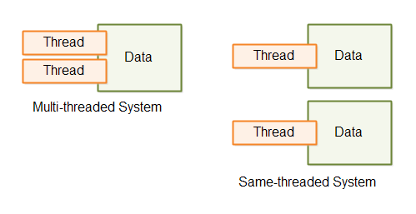

### Single-threaded Microservices

If your system consists of multiple microservices, each microservice can run in single-threaded mode. When you deploy multiple single-threaded microservices to the same machine, each microservice can run a single thread on a sigle CPU.

Microservices do not share any data by nature, so microservices is a good use case for a same-threaded system.

## Thread Communication

If the threads in a same-threaded need to communicate, they do so by message passing. A thread that wants to send a message to thread A can do so by generating a message (a byte sequence). Thread B can then copy that message (byte sequence) and read it. By copying the message thread B makes sure that thread A cannot modify the message while thread B reads it. Once it is copied it is immutable for thread A.

Thread communication via messaging is illustrated here:

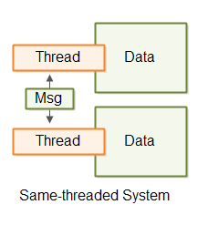

The thread communication can take place via queues, pipes, unix sockets, TCP sockets etc. Whatever fits your system.

**Concurrency vs Parallelism :**

**Concurrency :** Concurrency means that an application is making progress on more than one task at the same time.

if the computer has only one CPU the application may not make progress on more than one task at *exactly the same time*, but more than one task is being processed at a time inside the application. It does not completely finish one task before it begins the next.

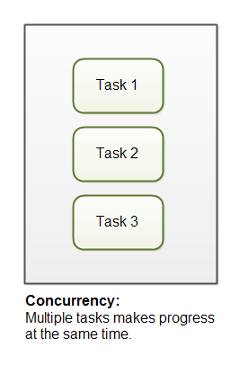

## Parallelism

Parallelism means that an application splits its tasks up into smaller subtasks which can be processed in parallel, for instance on multiple CPUs at the exact same time.

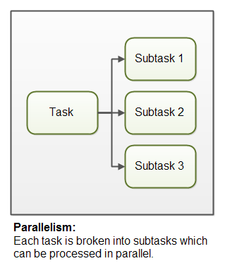

**Concurrency vs Parallelism :**

concurrency is related to how an application handles multiple tasks it works on. An application may process one task at a time (sequentially) or work on multiple tasks at the same time (concurrently).

Parallelism on the other hand, is related to how an application handles each individual task. An application may process the task serially from start to end, or split the task up into subtasks which can be completed in parallel.

As you can see, an application can be concurrent, but not parallel. This means that it processes more than one task at the same time, but the tasks are not broken down into subtasks.

An application can also be parallel but not concurrent. This means that the application only works on one task at a time, and this task is broken down into subtasks which can be processed in parallel.

Additionally, an application can be neither concurrent nor parallel. This means that it works on only one task at a time, and the task is never broken down into subtasks for parallel execution.

Finally, an application can also be both concurrent and parallel, in that it both works on multiple tasks at the same time, and also breaks each task down into subtasks for parallel execution. However, some of the benefits of concurrency and parallelism may be lost in this scenario, as the CPUs in the computer are already kept reasonably busy with either concurrency or parallelism alone. Combining it may lead to only a small performance gain or even performance loss. Make sure you analyze and measure before you adopt a concurrent parallel model blindly.

**Race Condition** : when order of execution changes the result then it is called race condition.

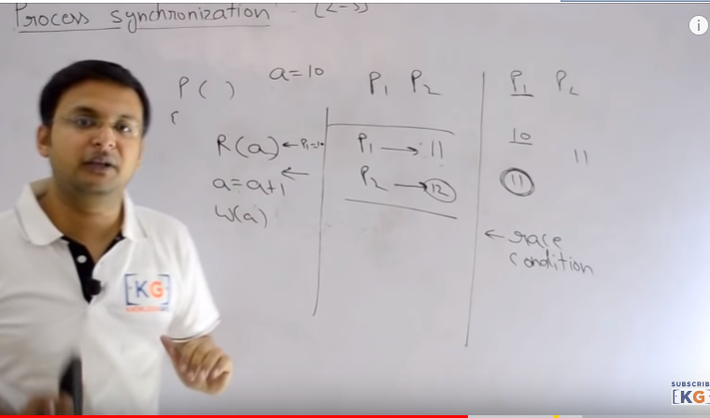

**Critical Section :** In the process execution Those area where we access shared resources is called critical section. So in Critical section two process should access the shared resource in systematic manner or mutually exclusive manner.ie only one process should come under critical section at a time. But if more than one process accesss the shared resource in a mixed fashion then it gives sometime inconsistent result and this is called **Race condition.**

**Ex:** public class Counter {

protected long count = 0;

public void add(long value){

this.count = this.count + value;

}

}

Imagine if two threads, A and B, are executing the add method on the same instance of the Counter class. There is no way to know when the operating system switches between the two threads. The code in the add() method is not executed as a single atomic instruction by the Java virtual machine. Rather it is executed as a set of smaller instructions, similar to this:

1. Read this.count from memory into register.
2. Add value to register.
3. Write register to memory.

Observe what happens with the following mixed execution of threads A and B:

this.count = 0;

A: Reads this.count into a register (0)

B: Reads this.count into a register (0)

B: Adds value 2 to register

B: Writes register value (2) back to memory. this.count now equals 2

A: Adds value 3 to register

A: Writes register value (3) back to memory. this.count now equals 3

The two threads wanted to add the values 2 and 3 to the counter. Thus the value should have been 5 after the two threads complete execution. However, since the execution of the two threads is interleaved, the result ends up being different.

In the execution sequence example listed above, both threads read the value 0 from memory. Then they add their i ndividual values, 2 and 3, to the value, and write the result back to memory. Instead of 5, the value left in this.count will be the value written by the last thread to write its value. In the above case it is thread A, but it could as well have been thread B.

**How to prevent race condition:** Race conditions can be avoided by proper thread synchronization in critical sections. Thread synchronization can be achieved using a [**synchronized block of Java code**](http://tutorials.jenkov.com/java-concurrency/synchronized.html). Thread synchronization can also be achieved using other synchronization constructs like [**locks**](http://tutorials.jenkov.com/java-concurrency/locks.html) or atomic variables like **[java.util.concurrent.atomic.AtomicInteger](http://tutorials.jenkov.com/java-concurrent-util/atomicinteger.html)**.

## Critical Section Throughput

For smaller critical sections making the whole critical section a synchronized block may work. But, for larger critical sections it may be beneficial to break the critical section into smaller critical sections, to allow multiple threads to execute each a smaller critical section. This may decrease contention on the shared resource, and thus increase throughput of the total critical section.

Here is a very simplified Java code example to show what I mean:

public class TwoSums {

private int sum1 = 0;

private int sum2 = 0;

public void add(int val1, int val2){

synchronized(this){

this.sum1 += val1;

this.sum2 += val2;

}

}

}

Notice how the add() method adds values to two different sum member variables. To prevent race conditions the summing is executed inside a Java synchronized block. With this implementation only a single thread can ever execute the summing at the same time.

However, since the two sum variables are independent of each other, you could split their summing up into two separate synchronized blocks, like this:

public class TwoSums {

private int sum1 = 0;

private int sum2 = 0;

private Integer sum1Lock = new Integer(1);

private Integer sum2Lock = new Integer(2);

public void add(int val1, int val2){

synchronized(this.sum1Lock){

this.sum1 += val1;

}

synchronized(this.sum2Lock){

this.sum2 += val2;

}

}

}

Now two threads can execute the add() method at the same time. One thread inside the first synchronized block, and another thread inside the second synchronized block. The two synchronized blocks are synchronized on different objects, so two different threads can execute the two blocks independently. This way threads will have to wait less for each other to execute the add() method.

[**Thread Safety and Shared Resources**](http://tutorials.jenkov.com/java-concurrency/thread-safety.html) :

Code that is safe to call by multiple threads simultaneously is called *thread safe*. If a piece of code is thread safe, then it contains no [**race conditions**](http://tutorials.jenkov.com/java-concurrency/race-conditions-and-critical-sections.html).

## Local Variables

Local variables are stored in each thread's own stack. That means that local variables are never shared between threads. That also means that all local primitive variables are thread safe. Here is an example of a thread safe local primitive variable:

public void someMethod(){

long threadSafeInt = 0;

threadSafeInt++;

}

Local object references : If an object created locally never escapes the method it was created in, it is thread safe.

Here is an example of a thread safe local object:

public void someMethod(){

LocalObject localObject = new LocalObject();

localObject.callMethod();

method2(localObject);

}

public void method2(LocalObject localObject){

localObject.setValue("value");

}

The LocalObject instance in this example is not returned from the method, nor is it passed to any other objects that are accessible from outside the someMethod() method. Each thread executing the someMethod()method will create its own LocalObject instance and assign it to the localObject reference. Therefore the use of the LocalObject here is thread safe.

# Thread Safety and Immutability : [Race conditions](http://tutorials.jenkov.com/java-concurrency/race-conditions-and-critical-sections.html) occur only if multiple threads are accessing the same resource, and one or more of the threads write to the resource. If multiple threads read the same resource [race conditions](http://tutorials.jenkov.com/java-concurrency/race-conditions-and-critical-sections.html) do not occur.

## The Reference is not Thread Safe!

It is important to remember, that even if an object is immutable and thereby thread safe, the reference to this object may not be thread safe.

Look at this example:

public class ImmutableValue{

private int value = 0;

public ImmutableValue(int value){

this.value = value;

}

public int getValue(){

return this.value;

}

**public ImmutableValue add(int valueToAdd){**

**return new ImmutableValue(this.value + valueToAdd);**

**}**

}

public class Calculator{

private ImmutableValue currentValue = null;

public ImmutableValue getValue(){

return currentValue;

}

public void setValue(ImmutableValue newValue){

this.currentValue = newValue;

}

public void add(int newValue){

this.currentValue = this.currentValue.add(newValue);

}

}

The Calculator class holds a reference to an ImmutableValue instance. Notice how it is possible to change that reference through both the setValue() and add() methods. Therefore, even if the Calculator class uses an immutable object internally, it is not itself immutable, and therefore not thread safe. In other words: The ImmutableValue class is thread safe, but the **use of it** is not. This is something to keep in mind when trying to achieve thread safety through immutability.

To make the Calculator class thread safe you could have declared the getValue(), setValue(), and add()methods synchronized.

# Java Memory model : The Java memory model specifies how the Java virtual machine works with the computer's memory (RAM). The Java virtual machine is a model of a whole computer so this model naturally includes a memory model - AKA the Java memory model.

# The Java memory model specifies how and when different threads can see values written to shared variables by other threads, and how to synchronize access to shared variables when necessary.

# Internal java memory model :

The Java memory model used internally in the JVM divides memory between thread stacks and the heap. This diagram illustrates the Java memory model from a logic perspective:

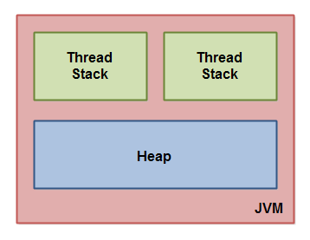

Each thread running in the Java virtual machine has its own thread stack. The thread stack contains information about what methods the thread has called to reach the current point of execution. I will refer to this as the "call stack". As the thread executes its code, the call stack changes.

The thread stack also contains all local variables for each method being executed (all methods on the call stack). A thread can only access it's own thread stack. Local variables created by a thread are invisible to all other threads than the thread who created it. Even if two threads are executing the exact same code, the two threads will still create the local variables of that code in each their own thread stack. Thus, each thread has its own version of each local variable.

Can we restart a dead thread? No

**Inter thread Communication :** It is important when we develop an application where two or more threads exchange some data and information. There are three different methods of class Objet ( **wait(), notify, notifyAll()** ) of Object class which makes it possible.

**Wait() :** On calling wait method the current thread must releases the ownership of this **monitor**(the object of that class which is holding the lock) and waits until another thread notifies the waiting thread on this object monitor to wake up. this can be done either through call by **notify()** method or by **notifyAll()** method.

There are three different wait method with different parameter:

1. Wait(long) 2. Wait(long , int) and 3. Wait()

**Note** : All three methods **wait() , notify() or notifyAll()** method must be called within the synchronized method/block otherwise it will be throw **IllegalMonitorStateException**

**notify() :** This method wakes up a single thread that is waiting on its object monitor. If any thread is waiting on this object one of chosen can be awaken. the choice is arbitrary and occurs at discussion of implementation. the thread will be awakened but this awakened thread cannot start execution until the current thread releases the lock on this object. This method can be called only by the thread that is owner of this object monitor . A thread becomes owner of the thread monitor as three ways :

**notifyAll()** : this method basically wakes up all the thread that are waiting on the object’s monitor. This method can only be called by thread that is owner of object’s monitor

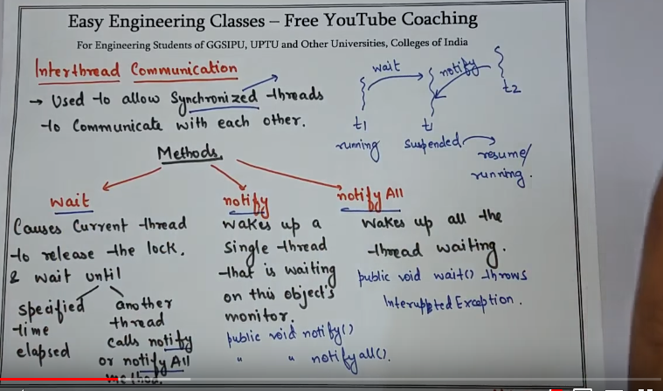

**Producer Consumer problem** :

